**WORKSHEET-3**

**SQL**

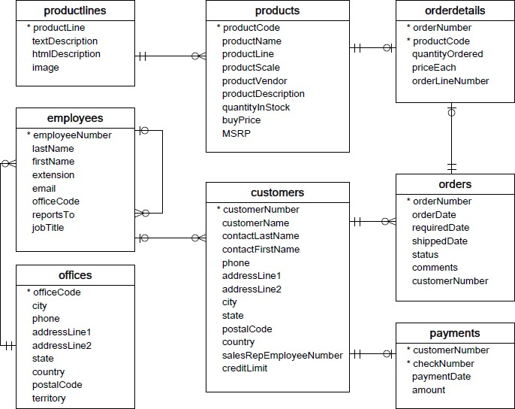**Refer the following ERD and answer all the questions in this worksheet. You have to write the queries using mysql for the required Operation.**

* **Customers**: stores customer’s data.
* **Products**: stores a list of scale model cars.
* **ProductLines**: stores a list of product line categories.
* **Orders**: stores sales orders placed by customers.
* **OrderDetails**: stores sales order line items for each sales order.
* **Payments**: stores payments made by customers based on their accounts.
* **Employees**: stores all employee information as well as the organization structure such as who reports to whom.
* **Offices**: stores sales office data.
  1. Write SQL query to create table **Customers.**

**create table Customers(**

**CustomerNumber int not null,**

**CustomerName varchar(30) not null,**

**ContactLastName varchar(30) not null,**

**ContactFirstNAme varchar(30) not null,**

**Phone int not null,**

**AddressLine1 varchar(30) not null,**

**AddressLine2 varchar(30),**

**City varchar(30) not null,**

**State varchar(30) not null,**

**PostalCode int not null,**

**Country varchar(30) not null,**

**SalesRepEmployeeNumber int not null,**

**CreditLimt int not null,**

**primary key (CustomerNumber),**

**foreign key (SalesRepEmployeeNumber) references Employees(EmployeeNumber));**

* 1. Write SQL query to create table **Orders.**

**create table Orders(**

**OrderNumber Varchar(30) not null primary key,**

**OrderDate date not null,**

**RequiredDate date not null,**

**ShippedDate date not null,**

**Stat varchar(10) not null,**

**Comments varchar(30) not null,**

**CustomerNumber int not null,**

**foreign key ( CustomerNumber) references Customers(CustomerNumber));**

* 1. Write SQL query to show all the columns data from the **Orders** Table.

**SELECT * FROM ORDERS;**

* 1. Write SQL query to show all the comments from the **Orders** Table.

**SELECT Comments FROM orders;**

* 1. Write a SQL query to show orderDate and Total number of orders placed on that date, from **Orders** table.

**select orderdate as dates, count(orderNumber) as no_of_order from Orders group by dates;**

* 1. Write a SQL query to show employeNumber, lastName, firstName of all the employees from **employees** table.

**SELECT EmployeeNumber,** **LastName,** **FirstName FROM Employees;**

* 1. Write a SQL query to show all orderNumber, customerName of the person who placed the respective order.

**SELECT Ordernumber,Customernumber FROM ORDERS;**

* 1. Write a SQL query to show name of all the customers in one column and salerepemployee name in another column.

**select customerName,salesRepEmployeeNumber from Customers;**

* 1. Write a SQL query to show Date in one column and total payment amount of the payments made on that date from the **payments** table.

**select paymentDate as PaidOn, amount from payments group by PaidOn order by PaidOn asc;**

* 1. Write a SQL query to show all the products productName, MSRP, productDescription from the **products** table.

**SELECT ProductName,** **MSRP,** **ProductDescription FROM Products;**

* 1. Write a SQL query to print the productName, productDescription of the most ordered product.

**productName,productDescription,max(quantityOrdered) from products,orderdetails where products.productcode=orderdetails.productcode;**

* 1. Write a SQL query to print the city name where maximum number of orders were placed.

**select ProductName,max(QuantityOrdered) from Products,Orderdetails where Products.productcode = Orderdetails.productcode;**

* 1. Write a SQL query to get the name of the state having maximum number of customers.

**select state,count(customerNumber) from customers group by state order by count(customerNumber) desc limit 1;**

* 1. Write a SQL query to print the employee number in one column and Full name of the employee in the second column for all the employees.

**select EmployeeNumber, concat(FirstName," ",Lastname) as Full_name from Employees;**

* 1. Write a SQL query to print the orderNumber, customer Name and total amount paid by the customer for that order (quantityOrdered × priceEach).

**select Orders.OrderNumber, Customers.CustomerName, orderdetails.QuantityOrdered*orderdetails.PriceEach as amount_paid**

**from((Orders**

**inner join Customers on Orders.CustomerNumber=customers.CustomerNumber)**

**inner join orderdetails on Orders.OrderNumber=orderdetails.OrderNumber);**